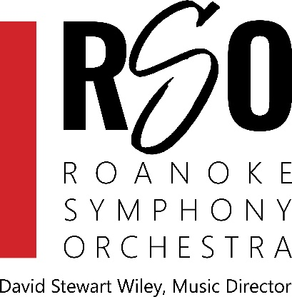
Roanoke Symphony Orchestra
David Stewart Wiley, Music Director and Conductor

Announces Auditions for
Principal Horn & Horn 3
on

Saturday, September 21, 2024
All audition candidates wishing to be invited should upload a one-page pdf resume focusing on orchestral experience, and at least 2 musical references (please include phone numbers). Applications must be completed by Friday, September, 13 2024. A $20 deposit is required to reserve your audition time. Deposit checks or money orders must be received by Monday, September 16, 2024 in order to be guaranteed an audition time. Please mail check or money order to the following address

Horn Auditions
Roanoke Symphony Orchestra
1125 1st St SW
Roanoke, VA 24016

Auditions are scheduled to start at 10:00 am, There will be an initial round of Horn excerpts and a brief solo of your choosing. Those who wish to be considered for Principal Horn will have a few extra excerpts to play in a later round. All rounds of the audition will be held behind a screen.

Please email any questions to RSOjobs@rso.com
No phone calls, please.
The RSO is a professional per-service orchestra offering travel reimbursement and hotel accommodations.
2024-2025 season per service fees are as follows:
Principals - $120.75 per service
Assistant Principals - $110.25 per service
Section - $99.75 per service

About the RSO
Soon to celebrate its 72nd season, the Roanoke Symphony Orchestra (RSO) and Chorus is the largest professional orchestra in Southwest Virginia with a stable annual budget of $1.7 million with a growing endowment.
Under the direction of Maestro David Stewart Wiley, RSO’s season consists of five Masterworks concerts, four Pops concerts, and other special services like summer parks concerts, destination series programs and opera services.
The RSO currently employs professional orchestra musicians from Virginia and neighboring states including West Virginia, Maryland, Ohio, Pennsylvania, New York, North Carolina, South Carolina, and Florida. Most are pleasantly surprised by the proximity of the beautiful Roanoke Valley to areas outside of Virginia. Our musicians find the RSO’s schedule and compensation to be an enjoyable way to supplement their yearly income while working in a musically rewarding atmosphere.

Auditions will be held at

Salem Presbyterian Church

41East Main St

Salem, VA 24153

Parking is located in the rear of the building at approximately 103 N Market St Salem, VA 24153.

Please enter the church at the rear or side entrance and follow the signs posted.

