VRATSA SYMPHONY ORCHESTRA
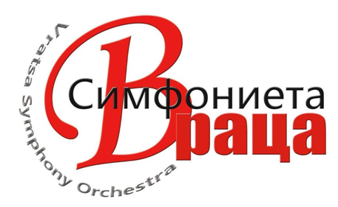
Section cello

Salary: 1700 Bulgarian Lev (лв)/month, gross average.

THE ORCHESTRA
The Vratsa Symphony Orchestra, located in picturesque and mountainous Vratsa, Bulgaria is a European (EU) state-funded orchestras. The musicians hail from over 16 different countries and foster a supportive and international environment for both national and international applicants. Concerts include frequent collaboration with international classical soloists and national Bulgarian crossover stars. With new initiatives, the VSO is expanding in size and members, and invites ambitious musicians who enjoy collaboration with diverse colleagues and who possess creativity to pursue other musical or non-musical interests. Rehearsals are conducted in Bulgarian and English. For non-EU members, the orchestra offers work permits and group language classes for smooth integration into Bulgaria work life. Season starts in February and continues until December. January is vacation. With a very low cost of living Vratsa is a peaceful and safe place to live for musicians. It is located close to the capital of Sofia, with very low-cost daily train/bus/auto schedules.

FINANCES COVERED
- Salary: 1700 leva. Тhis includes housing allotment of 365 лв, and is a pre-tax amount. Monthly pay depends on government working days, so pay may fluctuate a little up or down based on exact days worked, as per the government calendar. Amount listed is the monthly average.
- Full Medical Benefits
- Pension accumulation in Bulgaria
- Annual paid collective vacation (42 days), used together with the entire orchestra. January is off, plus other shorter breaks throughout the year, often including Orthodox Easter and other national holidays.
- Touring Expenses

HOUSING
The VSO assists to find accommodation. The orchestra offers double or triple occupancy apartments for 365лв, or members can use the housing allotment to find their own living arrangements.

AUDITION PROCESS
Submit all materials on Musical Chairs.

STAGE 1: SEND VIDEO RECORDING and RESUME
Submit the following:
1. Unedited video recording of you performing a solo piece of your choice, with a video length of 2-5 minutes. Video should show your whole body, no use of edits or sound alteration permitted.
2. Unedited video recording of 3-5 orchestral excerpts (of your choice of different instruments) from any standard audition repertoire.
3. A one-page CV

STAGE 2: ONLINE INTERVIEW
Successful candidates will be invited to an online Zoom interview.

STAGE 3: TRIAL PERIOD IN VRATSA, BULGARIA
Successful candidates will be invited to a paid trial period lasting 2-6 weeks in Bulgaria. Accommodation and salary will be provided during this period. Travel costs for candidates coming from within Europe will be covered. Candidates from other continents may receive partial reimbursement for flights. VSO assists with work permits for non-EU applicants.

JOB ТIMELINE
Duration/Start: To be arranged with the candidate, but we are looking to trial in September/October, depending on availability. Job offers may be made during trial, and start date to be arranged as soon as mutually agreed upon.
Location: Vratsa, Bulgaria (regular season), Europe (tours)

COST OF LIVING
Salary: 1700 лв/month
Bulgaria offers a low cost of living compared to other EU countries & has a very comfortable and extremely safe quality of life.

https://www.expatistan.com/cost-of-living/vratsa?currency=USD

https://visitmybulgaria.com/city-of-vratsa/

