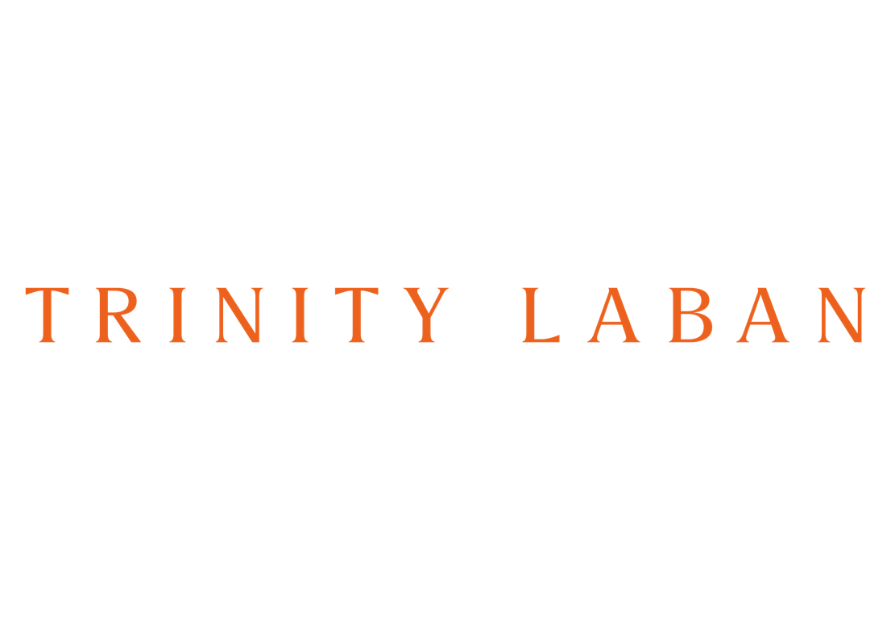

**Head of Development**Full-Time, Permanent

Contents

|  |  |
| --- | --- |
| Page 2 | Advertisement |
| Page 3 | Job Description |
| Page 6 | Person Specification |
| Page 7 | Conditions of Service Summary  and Staff Benefits |
| Page 8 | Information on Trinity Laban |

**Head of Development**

Contract: Full-time, Permanent

Salary: £61,680 - £70,796 (Including LWA)

We are seeking an exceptional fundraiser to motivate and lead our Development Department to achieve a fundraising step-change in support of this conservatoire’s ambitious Strategic Plan. Trinity Laban is striving to achieve excellence beyond tradition, creating a home for performing artists in which boundaries are pushed, collaborations are key, and artistic pioneers are made. We are a world-leading home for students from non-traditional backgrounds with a programme of activity that reaches out to all sections of society,   
centring the performing arts as a force for cultural and social progress.

Our Development Department is on a growth path, and this will be an exciting and career enhancing role for the right individual. With opportunities to build support for Trinity Laban and its students in a period of transformation and working with some of the most innovative and future-focussed artists of our time, there isn’t a better time to join the team.

We’re looking for someone with a strong track record of establishing and nurturing relationships with potential supporters with the capacity to make transformational gifts. You will be able to evidence successful complex institutional philanthropic bids and have experience of devising fundraising strategies supported by a compelling case for support. You will have opportunities to engage with partners and contacts globally and be based at our internationally renowned campus including the World Heritage Site in Greenwich and Stirling Prize Award-winning Laban Building.

You will be capable of leading and enabling the development team and a wider network of supporters and advocates focused on major gifts from individuals, artists, and influencers, as well as charitable trusts. You will bring an entrepreneurial and driving spirit and sophisticated communication and relationship skills, practised in operating at a strategic level. Informal enquiries should be addressed to Eva Woloshyn, Director of Corporate Affairs at [e.woloshyn@trinitylaban.ac.uk](mailto:e.woloshyn@trinitylaban.ac.uk)

As an equal opportunity employer, we positively encourage applications from suitably qualified and eligible candidates regardless of sex, race, disability, age, sexual orientation, gender reassignment, religion or belief, marital status, or pregnancy and maternity.

Please note all applications submitted will be shortlisted anonymously by our recruiting panel, so please ensure that your name and personal details are not included to your supporting statement, otherwise we will not be able to consider your application.

Closing Date: 23:59 hours BST, Tuesday 3 December 2024 (No Agencies)

Interview Date: Friday 13 December 2024

For any queries about this position that are not covered in the job pack, please email  
Katerina Filosofopoulou, Talent Resourcing and Organisational Development Officer on: [staffrecruitment@trinitylaban.ac.uk](mailto:staffrecruitment@trinitylaban.ac.uk)

All our taught programmes are validated by Trinity Laban Conservatoire of Music and Dance. Research degrees are validated by City, University of London. Trinity Laban Conservatoire of Music and Dance is a company limited by guarantee registered in England and Wales Company No. 51090. Registered Charity No. 309998.

**Job Description**

Post: Head of Development

Department: Development

Reporting to: Director of Corporate Affairs

Grade: Grade 9

Contract: Full-time, Permanent

Line management: Development Manager (Trusts and Foundations)

Development Officer

Additional resources: Marketing, design, alumni relations and data services   
within the Corporate Affairs directorate

Key internal

relationships: Principal, Board of Governors, Development Board, Senior

Executive team, art-form leadership across the institution

Context

The postholder reports to the Director of Corporate Affairs who is a member of the executive team. The head of development is member of the senior team for Corporate Affairs which together manages professional service departments focused on student recruitment and international relations, brand and communications, alumni relations, development, and data and business insights. A dedicated data manager maintains and supports the database through which development functions are managed; prospect management, gift processing, record-keeping, finance reconciliation, and reporting. The postholder will also work in collaboration with the Blackheath Halls which is engaged with local supporters.

The development department is small and highly focused, with capacity to grow. Its primary focus is on student scholarships for the most talented young artists in our artforms, gifts that enhance the student experience, and funding towards our internationally renowned campus buildings. It is a mature operation with well-established processes, and significant potential to build the number and scale of donations and grants. Philanthropy is well supported at senior level within Trinity Laban, and by the Chair of the Development Board who has recently taken on this role.

Purpose of Role

The role of the Head of Development is to enhance the work of Trinity Laban by securing support from philanthropic sources, commercial bodies, and other partnerships of value to the conservatoire. The department also leads or coordinates bids to public sector agencies and works closely with public engagement teams in support of their fundraising targets. The postholder will define and implement the next phase of strategic development to support Trinity Laban’s future aspirations, building on the influence and support of senior colleagues and volunteers.

* Revise and develop the development strategy from 2025, with the aim of increasing major gifts, public sector grants and corporate income, and creating the conditions for transformative donations.
* Support the work of the Development Board and other volunteers, and maintain and grow a culture of philanthropy across Trinity Laban
* Guide, motivate and empower the development department.

Main Duties

Strategic development and delivery

* Review and refresh the Development Strategy from 2025 to be aspirational and sustainable, and to substantially increase philanthropic support from major donors and charitable trusts.
* Work with the Chair of the Development Board grow and coordinate an active group of individuals dedicated to helping Trinity Laban fundraise
* Work closely with Board members, the Principal and other senior colleagues in the planning of donor solicitation, ensure their networks are effectively leveraged and opportunities are maximised.

Leadership and management

* Give leadership to all aspects of development and fundraising
* Maintain a culture of philanthropy, working closely with key stakeholders to develop advocacy and support for philanthropic activity
* Develop and empower a confident professional team to implement the fundraising strategy and to deliver on income targets
* Co-ordinate and maximise fundraising activity across other departments, including public engagement teams, and the Blackheath Halls
* Develop, monitor and deliver annual income targets and budgets, providing regular reports as needed.

Fundraising and donor stewardship

* Manage and grow a personal portfolio of major gift prospects and donors, developing long-term donor relationships to secure high value gifts
* Lead on approaches to major donors, engaging senior leadership and volunteers, producing tailored proposals and impact reports as necessary.
* Ensure a consistent and maximised programme of bids to charitable trusts and foundations.
* Seek out and maximise public sector funding opportunities.
* Develop and grow legacy giving and other strands of philanthropic income
* Develop a suitable programme to encourage alumni giving
* Deliver an outstanding donor experience, and high quality and engaging supporter communications
* Maintain a strong pool of potential prospects and donors.
* Ensure the highest standards in fundraising and compliance with the Code of Fundraising Practice

The above list is not exclusive or exhaustive and the post holder will be required to undertake such duties as may reasonably be expected within the scope and grading of the post.

The Postholder must:

* Be available to work evenings and weekends as necessary to attend events and performances
* Be available for regional or overseas travel from time to time
* At all times be committed to Trinity Laban’s Equality and Diversity Policy.
* Adhere to all policies and procedures relating to Health and Safety in the workplace.

Conservatoire Values:

All staff are expected to operate in line with Trinity Laban’s Terms and Conditions for staff, which set out the principles of how we work together. More information about the Conservatoire’s vision, mission and values is available at <https://www.trinitylaban.ac.uk/about-us/>.

All members of staff are required to be professional, co-operative and flexible in line with the needs of the Conservatoire.

Trinity Laban has a no smoking policy on its premises.

**Head of Development**Person Specification

|  |  |  |  |
| --- | --- | --- | --- |
| **Criteria** | **Specification** | **E/D** | **Measured By** |
| **Education /**  **Qualifications** | Educated to degree level. | Essential | Application |
| Relevant fundraising training / qualifications. | Desirable | Application |
| **Experience** | Securing major gifts from individuals at the 5-figure level and above. | Essential | Application |
| Fundraising from charitable trusts and public funding sources. | Essential | Application |
| Design and delivery of successful fundraising campaigns or appeals. | Essential | Application |
| Leading and motivating a fundraising team. | Essential | Application |
| Working with a Development Board or senior volunteers to secure philanthropic support. | Essential | Application |
| Use of a CRM database to support, track, and report upon fundraising activity | Desirable | Application |
| **Knowledge /**  **Understanding** | Knowledge of the Higher Education and/or music, dance or musical theatre sectors, and the issues facing them. | Essential | Application |
| Understanding of key conditions for successful fundraising from individuals, trusts, public funding agencies, and business interests. | Essential | Interview |
| **Skills and**  **Abilities** | Excellent interpersonal, communication and presentation skills, with the ability to explain cases cogently and to a varied audience. | Essential | Interview |
| Capacity to negotiate through personal influence. | Essential | Interview |
| Ability to develop strong relations with high-level prospects, donors and stakeholders. | Essential | Interview |
| Enterprising and entrepreneurial approach with the ability to spot and maximise opportunities. | Essential | Interview |
| Ability to work collaboratively. | Essential | Interview |
| **Personal Qualities** | Highly motivated to achieve challenging targets. | Essential | Interview |
| Gravitas, and a confident approachable manner that engenders trust. | Essential | Interview |
| Positive, resilient, innovative and solutions orientated. | Essential | Interview |
| **Special Working**  **Requirements** | Ability to travel from time to time both in the UK and overseas and to attend events and meetings outside normal working hours. | Essential | Application |

Please note that it will not be possible for the Conservatoire to issue a Certificate of Sponsorship for the successful candidate as we are awaiting further information from UK Visas and Immigration. Applicants will therefore need to be eligible to work in the UK or have limited leave to remain in the UK and associated right to work for the duration of their employment with the Conservatoire, in accordance with the Immigration, Asylum and Nationality Act 2006.

**Conditions of Service Summary   
& Staff Benefits**

Contract: Full-Time, permanent, subject to a 6-month probationary period.

Hours: 35 hours per week, usually from 9.00 am to 5.00 pm Monday to Friday, (with a daily lunch break of one hour). Evening and occasional weekend working will be required.

Location: You will be based at King Charles Court, Old Royal Naval college but will also be required to work at the Laban building, Creekside, and to visit Blackheath Halls from time to time.

Salary: Trinity Laban Staff Salary Scale, Grade 9, point 44 - 49, £61,680 - £70,796 inclusive of a London Weighting Allowance of £4,259 p.a. However, the salary will be commensurate with experience and/or reflective of the wider labour market. Salaries are paid on the last working day of each month direct into bank or building society accounts.

Holidays: 25 days p.a. in addition to Statutory, Bank and Public Holidays.

Sick Pay: Trinity Laban operates the Statutory Sick Pay Scheme, and staff may be eligible for benefits in excess of this under Trinity Laban’s own sick pay scheme.

Pension Scheme: The successful candidate will be auto-enrolled into the Universities Superannuation Scheme if they meet the qualifying criteria. Employees contribute at the rate of 6.1% of their pensionable salary. The Conservatoire pays the Employer’s contribution currently at the rate of 14.5% of pensionable salary.

Staff

Development: A range of Staff Development opportunities are available.

Library: The Laban Library & Archive and the Jerwood Library of the Performing Arts are available for use.

Car Parking: A limited number of parking spaces are available at the Old Royal Naval College and the Laban Building, subject to availability.

Cafeteria: Our Cafeterias/Licensed Bars at both sites serve a range of hot and cold drinks and snacks.

Events: There is a wide range of music and dance performances each week,   
many of which are free to members of staff.

Classes: Free weekly staff Pilates class as well as reduced rates and access to Adult Classes.

Eye Care: Vouchers for eye tests are available for VDU users.

Health:   Reduced rates for Health services and access to the Cash 4 Health plan. Details are available from the Health Department.

Cycle to Work:   A cycle to work scheme is operated

Give as you earn:   A give as you earn scheme is operated.

Information on Trinity Laban

Trinity Laban Conservatoire of Music and Dance is the UK’s only conservatoire of music and contemporary dance. The unequalled expertise and experience of its staff, and its world-class facilities housed in landmark buildings, put Trinity Laban at the forefront of vocational training in music, musical theatre, and dance.

Our history goes back to 1872 with the founding of Trinity College of Music in London. Trinity College of Music merged with Laban (founded in 1946) in 2005 to create Trinity Laban, now home to a creative and cosmopolitan community of students, teachers and researchers from around   
the globe.

We have a reputation for innovation and forward-thinking and are focused on training students   
for life-long careers in our art forms. Each year we welcome over 1,000 students from over 60 countries to follow undergraduate, postgraduate and research programmes. Thousands more people enjoy music, dance and health activities as part of our lively performance and outreach programmes.

Our unrivalled roster of teaching staff includes respected academics, performers, composers and choreographers. Many of them are active researchers who push at the boundaries of their art forms and extend our understanding of artistic and educational practice. We also welcome leading visiting artists, ensembles and companies from around the world, so our students benefit from working directly with today’s top performers.

We work in a number of outstanding locations, including the 17th-century Old Royal Naval College at Greenwich (a World Heritage Site), the Stirling Prize-winning Laban Building in Deptford, and the magnificent Grade II listed Blackheath Halls. Our world-class facilities include state-of-the-art practice rooms and dance studios, flexible performance spaces and internationally famous libraries. Students also have access to the cultural wealth of London, and regularly perform at its leading venues. To find out more, visit [www.trinitylaban.ac.uk](http://www.trinitylaban.ac.uk)