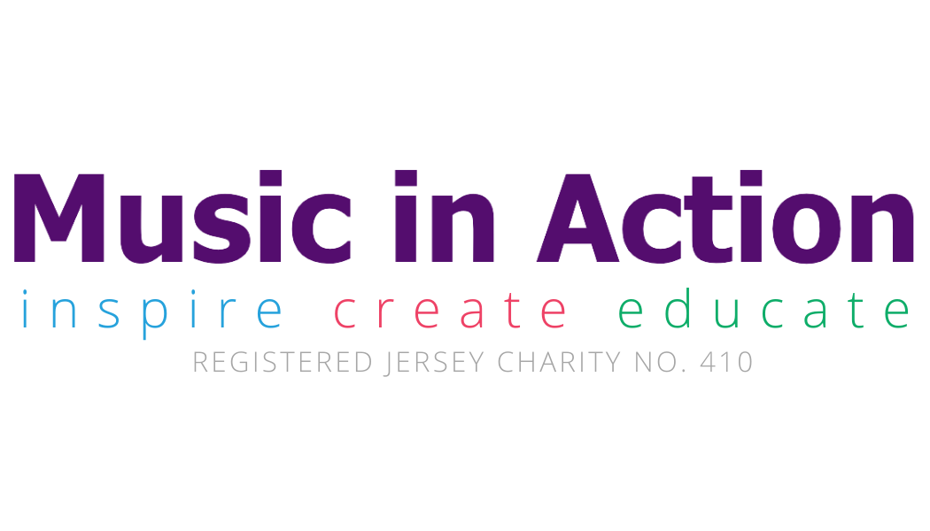

Festival Artist and Events Manager
Music in Action is seeking to recruit a highly motivated arts professional to the post of Festival Artist and Events Manager. This role will be responsible for the curating, management and organization of some of the work carried out flowing from Jersey’s Liberation International Music Festival and fundraising events in the UK, Europe and internationally.
Music in Action uses music as an educational, therapeutic and occupation tool to educate students, the sick and infirm to have relief, and to organise a cultural programme of the highest quality. Our mission is to enrich and transform lives and communities through music.
The successful application will work alongside a motivated and enthusiastic team based in Jersey and depending on the balance of the team may be on a part-time role of 1 to 2 days per week.
The role is to assist in arranging a series of fundraising candlelight concerts in the UK, to take shows developed for Jersey such as a show involving music and words about Jersey wartime activist Claude Cahun and arrange for subsequent performances in the UK and Europe, and curate concerts with Festivals Artists such as Harriet Mackenzie, Willard White, and Alexander Sitkovetsky who are working on chamber music projects for Jersey to have a wider reach and be performed outside Jersey.
Once the events are arranged then the role would turn to an artist liaison/ management type role including the administration of contracts, assisting in marketing the programme as required & the logistics and organization of the events.
The Festival Artist and Events Manager’s role includes:
- Using contacts gained as an artist manager to book Jersey’s events in the UK, Europe or internationally;

- Assisting when required with marketing including involvement with local media and social media, as required helping design publicity and help to market the events, preparing or supervising or carrying out the preparation of publicity and its distribution;

- Organize and project manage events including liaising with musicians, venues, preparing & disseminating schedules, directing the managing of events (subject to availability and location), booking artists and risk assessments.
The Festival Artist and Events Manager is expected to work for around 15 to 20 concerts each year and the role is expected to be carried out remotely by someone UK based.
Reporting Line
The Festival Artist and Events Manager reports into the Chairman, Music in Action.

Specification:
- Contact list and links to major venues in UK and Europe, (ideally US and Asia as well but not essential)
- Strong written and verbal communication skills, with good interpersonal skills for communicating with Venues, Press, Artists, Hosts, sponsors and donors.
- A team player with the ability to inspire and motivate others
- Ability to remain calm under pressure and to think on one’s feet
- Ability to set, plan and prioritise tasks and resources to meet deadlines and manage time effectively, with the ability to pay attention to detail
- Strong skills in event management.
- Good IT skills across all applications including word, excel and databases
- Knowledge of music is ideal.

Dated: 30 November 2024

